

**Surgical Mask Extenders**

Medical professionals now must wear surgical masks the entire time they are on their shift. The bands attached to the masks can cause irritation to the skin behind the ears, thus making them uncomfortable to wear for long periods of time. These mask extenders reduce the pressure behind the ears, affording the user an increased measure of comfort. These original design was from HP as a 3D print model but the extenders can be made in a variety of ways. The information and files provided in the zip file can be used to make extenders.

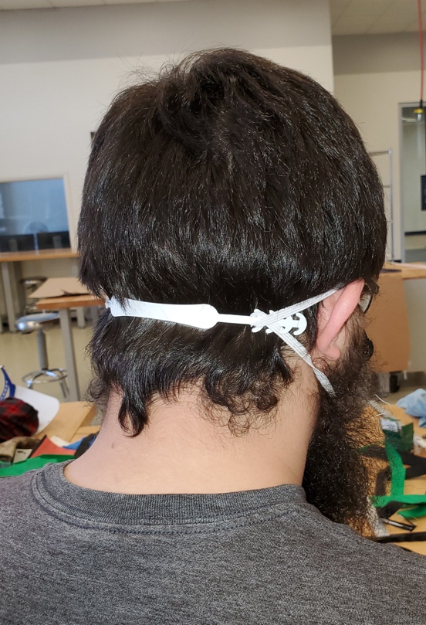**Rough Dimensions:**  
7.5”x .56” x .06” Thickness (any thicker may not flex)

**Materials:**   
Thin flexible plastic that can withstand a chlorine wipe (e.g., PETG, PVC, polypropylene)

**Processes:  
•** 3D Printing **•** Laser Cutting **•** Water Jet

**Cleanliness Instructions:**

• Wear nitrile gloves while handling

• Wear face protection while handling

• When completed please place finished parts into   
 a sealed Ziploc bag

• Wipe parts down with a chlorine or sterilizing   
 wipe (medical professionals will clean them once   
 they are delivered as well)

**Files in Folder:**

.IGES

.STEP

.STL

.DXF

**Production Questions:**

Inquiries regarding the template or processes contact Kelsey Crawford, Kelsey Crawford at [kelsey.crawford@mail.wvu.edu](mailto:kelsey.crawford@mail.wvu.edu) or Josh Bintrim at [josh.bintrim@mail.wvu.edu](mailto:josh.bintrim@mail.wvu.edu)

**Delivery:**

The Innovation Hub at the Statler College will serve as a central point of contact to deliver extenders for distribution to WVU Health Sciences and local healthcare facilities in need. Contact Gene Cilento, Innovation Hub Director at [Gene.Cilento@mail.wvu.edu](http://Gene.Cilento@mail.wvu.edu/), 304-293-4088 for distribution.